

**Gold Coins and Personal reflection**

           Semester 1, 2019  **Plagiarism**

According to the *Academic integrity policy*, plagiarism is:

*"Claiming and using the thoughts or writings or creative works of others without appropriate acknowledgement or attribution.  It includes:  
(a)  copying part or all of another student's assignment;  
(b)  allowing another person to write some or all of an assignment;  
(c)  copying paragraphs, sentences or parts of sentences directly from texts or the internet without enclosing them in quotation marks or otherwise showing them to be copied - even if the source is acknowledged, this is still plagiarism;  
(d)  using concepts or developed ideas, even if paraphrased or summarised, from another person, from texts or the internet without acknowledging the source;  
(e)  copying graphics, architectural plans, multimedia works or other forms of intellectual property without appropriate acknowledgment."*

The consequences of plagiarism (depending on the seriousness of the case) range from reducing your mark or failing the assignment up to a formal reference to a summary inquiry:

|  |
| --- |
| *By signing below I certify that the attached assignment is my own work.*   Student Id:                             Student Name:                                          Signature: |
|  |

**Assessors Comments & Grade:**

# Individual Debriefing Report and Group Participation

You are required to prepare a reflection about your group’s performance and allocate gold coins to reflect the participation of each group member.

Your report is in **three** parts:

1. A project reflection;
2. An allocation of 100 gold coins to each member of your group (including yourself); and
3. An assignment knowledge.

**Project Reflection:**

In your project reflection discussion you are to

1. Consider how your group worked and how well it performed in achieving its goals.
2. What would you change if you had your project time again?
3. What would you leave unchanged?

**Gold Coin Allocation:**

The material in part 2 of this report is used to assist us in the assessment of the contribution that each team member made to the team’s project.

Each team member receives a mark out of 10 to reflect this contribution based on your comments, the comments and gold coins allocated by the other members of your team, and input from your tutor and the lecturer.

The assessment of this report is managed in three parts:

1. Your Reflection and your Gold Coin Allocation will assessed for the quality of your evaluation and insights into your project, group processes, and comments on your team member and your own contributions; and
2. The perceived value of your contribution to the design project by your team members and your tutor.
3. The design of your document quality statement and the application of the associated quality measures.

**Individual Debriefing Report :: Part 1**

**Part 1. Confidential Reflection on Project.**

*A Critique of the project and its development:*

***For things that went wel****l*

*what were they, how did they benefit your group work and project?*

Có cơ hội học hỏi được nhiều thứ và kiến thức mới từ project.

***For things that did not go well***

*what were they, why did they happen, what might have happened, what skills or knowledge did you not have, how should you have acquired them?*

Chưa sắp xếp thời gian của cá nhân và nhóm hợp lý.

***In what ways could the group work have been improved?***

* Lập kế hoạch rõ ràng
* Phân chia công việc cụ thể
* Hỗ trợ giúp đỡ lân nhau

***Your design, documentation and presentation techniques***

*how satisfactory were they?*

* Trình bày bố cục rõ ràng xúc tích, đầy đủ những công việc đã làm.

***Your finished product***

*give a brief assessment.*

Mặc dù đã cố gắng những chưa thật sự hoàn hảo.

##### **A Bibliography of reference to group work**

Google

**Individual Debriefing Report : Part 2**

**Part 2. Confidential Team Evaluation**

For each of your team members (including yourself), summarise and comment on their contribution to the work (consider their attitudes especially willingness to contribute), knowledge, written contribution, attendance at meetings, contribution to the presentation, helping keep the group together and working well, leadership, etc). If your team was given **100 gold coins** to reward it for its work, how many coins would each member get (including yourself)?

**Team Member Name Contribution: Number of Coins**

1: My name: Nguyễn Tường 35

2: Đinh Nam Thuận

3: Nguyễn Lương Quảng 35

**Total Coins = 100**

**Individual Debriefing Report : Part 3**

**Part 3. Course Knowledge**

1. A realtime system consists of four threads named A, B, C and D that communicate through two monitors M1 and M2. The graph below shows the monitor methods called from each thread, annotated with the worst case execution time per method. The table shows the period (T) andworst case execution time (C) for each thread. Calculate the worst case response times for the fourthreads. The system is scheduled using RMS and utilizes the basic inheritance protocol. All timesare given in milliseconds.

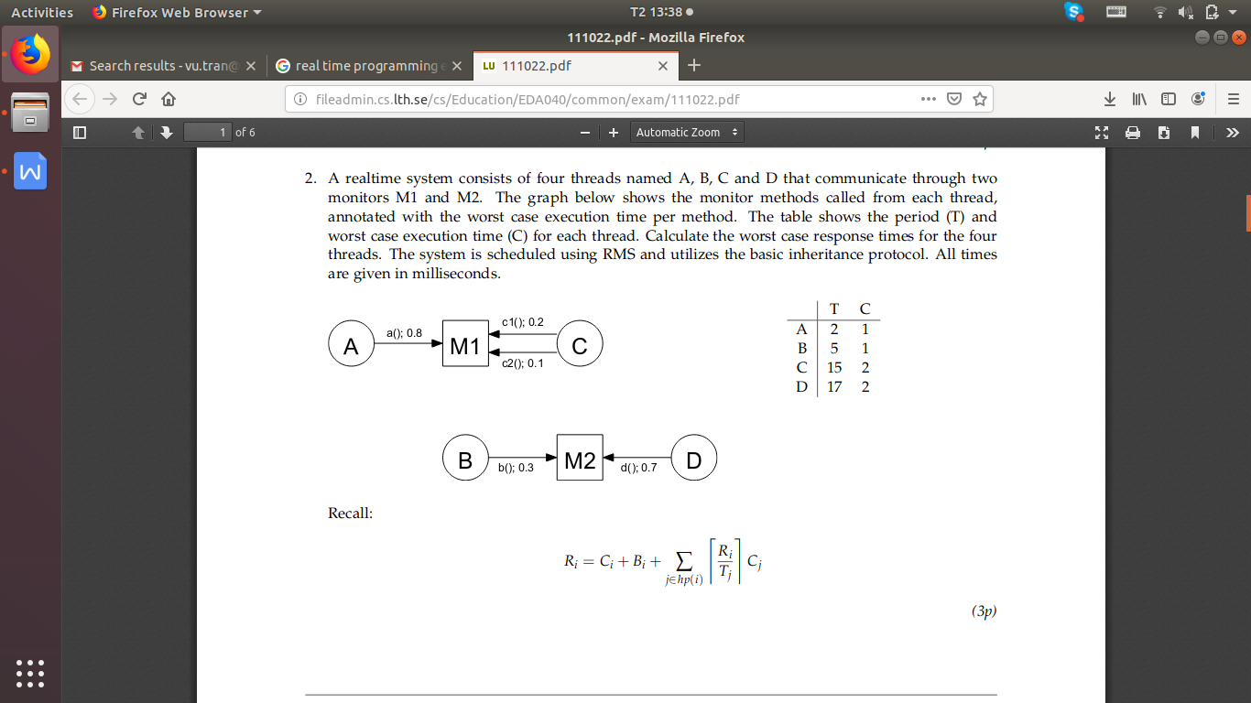

1. A real-time system with strict priorities is to be scheduled with fixed-priority scheduling, withpriorities assigned according to the deadline-monotonic principle. It is ensured (by detailed knowl-edge about the application, the run-time system and its hardware) that blocking times do not causemore than 4ms delay per thread. It is desirable that a set of (the highest priority) threads forfeedback control has priorities assigned in the order A, B, C, and D. The table below gives partialinformation about the system

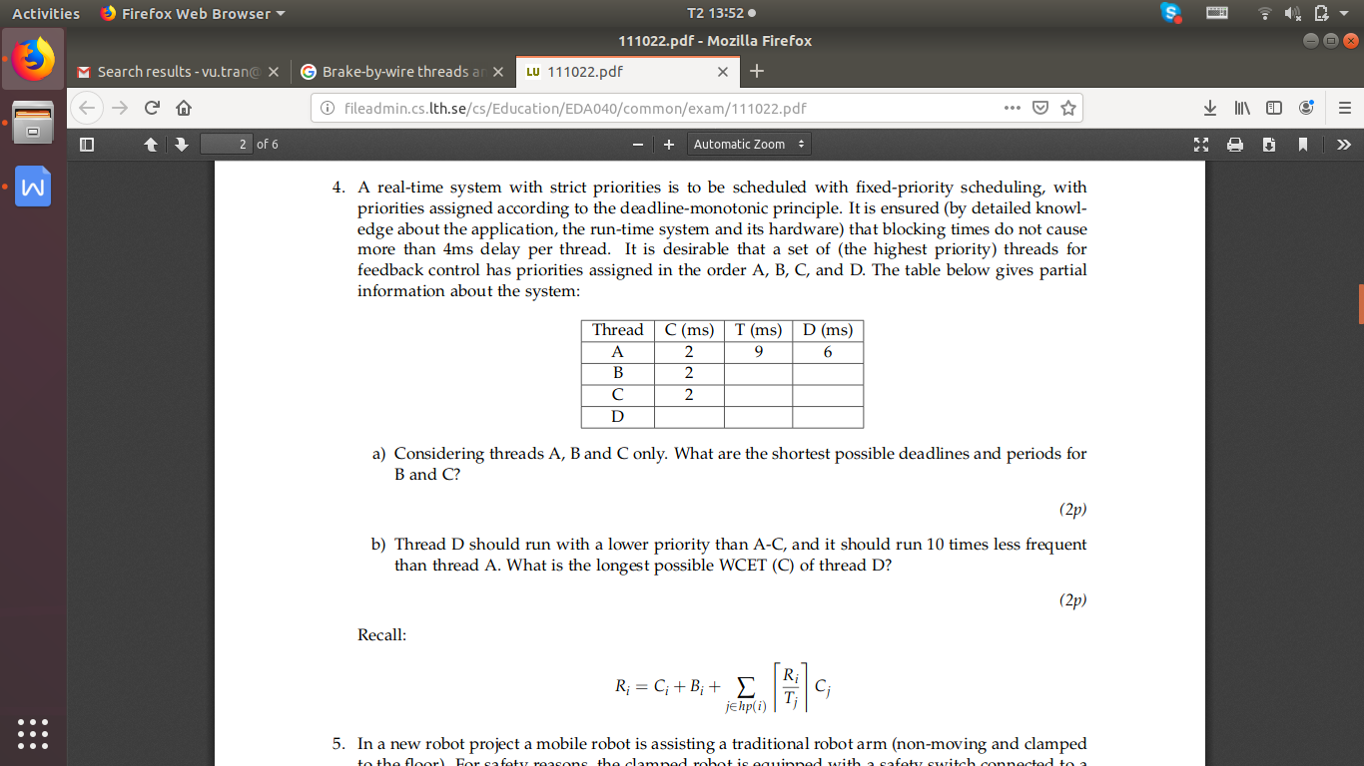

1. Considering threads A, B and C only. What are the shortest possible deadlines and periods for B and C?
2. Thread D should run with a lower priority than A-C, and it should run 10 times less frequentthan thread A. What is the longest possible WCET (C) of thread D?

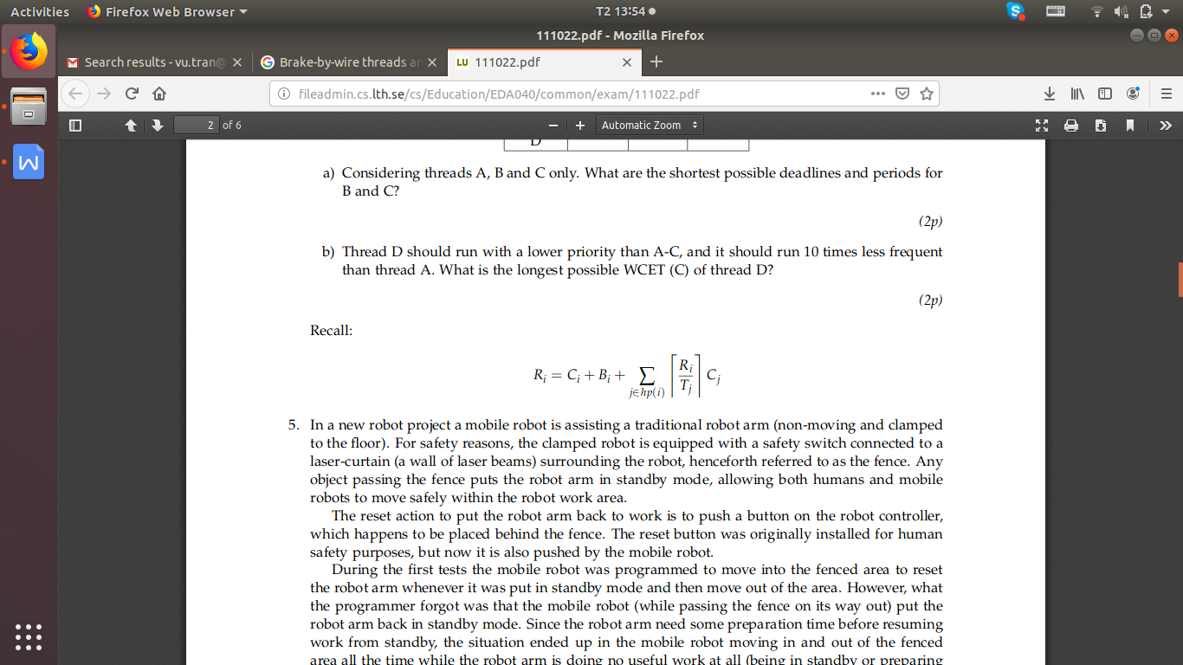**Part 4. Document Quality Statement**

The quality could be applied to this document:

* Quality of answer is matched with expectation of the question
* The answers reflect real status of group and project
* Arguments in the report are support by example/evidence/issues/events
* Gold coins deliver to each member is correct (reflect their actual contribution to project)

This document is reflection of my though based on the experience that I have and the written notes through the project.